Clinical presentation of hereditary fructose intolerance prior to beikost - what excipients can do
Apresentação clínica da intolerância hereditária à frutose prévia à diversificação alimentar – o papel dos excipientes
Short title: Hereditary fructose intolerance prior to beikost
Type: Clinical case
Filipa M. A. Dias, M.D.¹, Fernando Tapadinhas, M.D.², Ana C. Ferreira, M.D.³, Sílvia Sequeira, M.D³
¹ Department of Pediatrics, Hospital de Faro, Centro Hospitalar do Algarve, Portugal. ana.filipa.mestre@gmail.com
² Neurodevelopmental Center, Department of Pediatrics, Hospital de Faro, Centro Hospitalar do Algarve, Portugal. ftapadinhas@hotmail.com
³ Metabolic Unit, Paediatric Department, Hospital de Dona Estefânia, Centro Hospitalar de Lisboa Central, Portugal.
anacrisferreira@clix.pt; silviasasequeira@gmail.com
Conflict of interest: We report no conflict of interest.
The first graft of this manuscript was done by the first author with no grants or monetary profit.
Corresponding author:
Filipa Mestre A. Dias
Address: Urbanização Santo António do Alto, bloco 81 – 1º direito. 8000-536 Faro
ana.filipa.mestre@gmail.com
Resumo:
Os autores descrevem um caso de intolerância hereditária à fructose (IHF) com apresentação clínica prévia à diversificação alimentar: lactente de dois meses, que apresentou um primeiro episódio de hipoglicemia sintomática (crise convulsiva generalizada), durante uma infecção respiratória febril dispneizante, sob terapêutica com claritromicina e betametasona orais. Aos nove meses apresentou um segundo episódio de hipoglicemia após ingestão de um iogurte de aromas. A evidência de hepatomegalia e os achados laboratoriais sugeriam o diagnóstico de doença de Von Gierke, não confirmado por estudos moleculares. Posteriormente, a mãe relatou episódios repetidos de vómitos, duas horas após a ingestão de certos alimentos, que levou à suspeita clínica de IHF, confirmada por análise genética.
Poucos casos estão descritos de descompensação metabólica de IHF prévia à diversificação alimentar, sobretudo em lactentes exclusivamente amamentados. Concluímos que algumas formulações pediátricas utilizadas rotineiramente contêm excipientes que podem estar na origem de descompensação metabólica da IHF.

Palavras-chave: Hipoglicemia, intolerância herediária à frutose, doença de Von Gierke, excipien
Abstract:
We report a case of hereditary fructose intolerance (HFI) with clinical onset prior to beikost: A two-month-old infant who had a first symptomatic hypoglycemic episode (generalized motor epileptic crisis) during a febrile respiratory infection with dyspnoea, while medicated with clarithromycin and betamethasone oral formulations. At nine months he presented a new hypoglycemic episode two hours after eating a flavored yogurt. The hepatomegaly and laboratory findings suggested the diagnosis of Von Gierke’s disease, not confirmed by molecular studies. There after, mother reported repeated vomiting episodes two hours after the ingestion of certain foods, leading to the clinical suspicion of HFI, subsequently confirmed by genetic analysis. There are few cases reporting metabolic decompensation of HFI prior to complementary feeding, mainly in exclusively breastfed children. We concluded that some routine formulations have excipients that can precipitate metabolic decompensation in HFI.

Keywords: Hypoglycemia, Hereditary Fructose Intolerance, Von Gierke’s disease, excipients
Introduction
Hypoglycemia is a common event to several clinical entities, including poisoning, several endocrine disorders and inborn errors of metabolism. It should be rapidly recognized, promptly treated and the etiology investigated in order to establish a therapeutic plan and minimize the long-term consequences ^{1, 2}.
In a state of metabolic decompensation, laboratory changes are frequently overlapping, making the diagnosis difficult. Genetic analysis has given an important contribution^{3,4}, but careful anamnesis may be still the key to help identify the underlying cause.
HFI clinical presentation rarely occurs prior to beikost - in breastfed infants finding the cause of metabolic decompensation can be almost a detective work.

Case report:
A male infant, only child of young, healthy and unrelated parents, had an unremarkable birth and neonatal period, with no episodes of hypoglycemia and a negative metabolic screening. Breastfeeding was exclusive up to 5.5 months.

At 2 months, he was treated with clarithromycin pediatric oral suspension - Klacid pediátrico® (Abbot laboratories), betamethasone oral solution - Celestone® 0,5mg/mL oral solution (Merck Sharp & Dohme, Lda) and nebulized salbutamol for a febrile respiratory infection with associated dyspnoea. While on this medication he presented symptomatic hypoglycemia (plasma glucose 0.4mmol/L [7mg/dL]) manifested by a generalized motor crisis with clonic movements of the four limbs. He was being exclusively breastfed, had no history of vomiting and the physical examination was normal including the absence of abdominal organomegaly.
At 9 months, in the course of persistent vomiting two hours after eating a flavored yogurt, he had a new episode of symptomatic hypoglycemia (blood glucose 1.3mmol\L [23mg/dL]), manifested as marked prostration and drowsiness. The physical examination showed an age appropriate growth and psychomotor development and hepatomegaly 7cm below right margin rib. Blood tests revealed metabolic acidosis with hyperlactacidemia (lactic acid 4.8mmol/L) hyperuricemia (uric acid 369μmol/L), hyperlipidemia (LDL cholesterol 3.55mmol/L and triglycerides 2.17mmol/L) and hypertransaminasemia (alanine aminotransferase 147 IU/L and aspartate aminotransferase 438 IU/L) subsequently reverting to normal levels. Clotting times were normal. Urine reducing substances were negative (urine collected one week after the period of symptomatic hypoglycemia) and so was the chromatography of urinary sugars. Abdominal ultrasonography confirmed the hepatomegaly and suggested hepatic steatosis.
Insulin, C-peptide, growth hormone, IGF-1 and IGF-1-BP3 showed normal levels.
The triad of lactic acidosis, hyperuricemia and hyperlipidemia in a child with symptomatic hypoglycemia and hepatomegaly suggested the diagnosis of type Ia glycogen storage disease (Von Gierke's disease). However, the molecular assay of the glucose-6-phosphatase gene was normal.
Reviewing the history, it is noticed that the child has refusal of certain foods, namely fruit, some soups and flavored yogurts presenting intermittent vomiting episodes (about 2 to 2.5 hours after the meal) after eating small quantities of these foods.
Despite the clinical onset of symptomatic hypoglycemia long before the beikost, the lack of urinary reducing substances and repeated normal urine sugar chromatography, the anamnesis, hepatomegaly and high transaminases suggested the diagnosis of Hereditary Fructose Intolerance (HFI). This hypothesis was tested and confirmed by genetic analysis of the aldolase B gene revealing the p.R60X and p.A175D mutations respectively on exons 3 and 5.
A diet free from fructose, sucrose and sorbitol was started and there was complete recovery of the laboratory abnormalities and hepatic steatosis. The child has not had any more hypoglycemic episodes and is achieving age appropriate developmental milestones, weight and growth.
Discussion:
HFI is inherited as an autosomal recessive disease with an estimated prevalence of over 1:26 000 live births in Europe⁴. This condition results from deficit of fructose-1,6-bisphosphate aldolase (aldolase B) which, in the presence of fructose, sucrose (glucose + fructose) or sorbitol leads to the accumulation of fructose 1-phosphate, a toxic metabolite which inhibits the process of gluconeogenesis resulting in hypoglycemia⁵. The onset of clinical manifestations prior to beikost is classically linked to formulas containing one of those sugars (such as soy formulas) and there are few descriptions of symptoms during exclusive breastfeeding^{6, 7}. Nevertheless, many pediatric drugs⁸ such as oral suspension of clarithromycin⁹ and betamethasone oral solution¹⁰, contain sucrose (glucose and fructose) and sugar alcohols as part of their excipients. The drugs given to our patient were probably responsible for the metabolic decompensation and the early onset symptoms of HFI.
In this particular case, the onset of symptoms before the beikost and the association of lactic acidosis, hyperuricemia and hyperlipidemia (which later was found not to be persistent) concomitant with hypoglycemia, hepatomegaly and hepatic steatosis suggested the diagnosis of type Ia glycogen storage disease. However, the refusal of fruit, yogurt and some sweet vegetables like carrots, the repeated episodes of vomiting and hypoglycemia occurring about 2 to 2.5 hours after a meal containing these made the HFI hypothesis more reasonable.
Hepatic steatosis with mild to moderate elevation of aminotransferases is described as part of the HFI clinical picture, sometimes compensated and silent. Proximal tubular dysfunction (Fanconi syndrome) is also described in both type Ia glycogen storage disease and HFI.
The absence of urinary reducing substances and the normal urinary sugar chromatography also hampered our initial diagnostic investigation. These are almost invariably present in HFI during periods of decompensation¹. However, if urine collection is made outside this period or if the patient has total refusal of foods containing fructose, they loose diagnostic value.
The anamnesis, which highlighted the child´s selective food refusal and the short time between the previous meal and the emerging symptoms of hypoglycemia, proved to be pivotal to find the diagnosis. Genetic testing confirmed the diagnosis¹¹.
We remind that sucrose and sorbitol, often used as excipients in pediatric formulations (Fig. 1), are not always harmless² and may trigger metabolic decompensation in children not yet diagnosed with inborn errors of metabolism and emphasize the need of a careful anamnesis, as the laboratory findings can sometimes be treacherous and misleading.
References:
- Kishnani PS, Chen YT. Defects in Metabolism of Carbohydrates. In: Kliegman R, Stanton B, St. Geme III J, Schor N, Behrman R, editors. Nelson Textbook of Pediatrics. 19th edition. Philadelphia, Elsevier Saunders, 2011: 503-505
- Valayannopoulos V, Romano S, Mention K, Vassault A, Rabier D, Polak M, et al. What’s new in methabolic and genetic hypoglycemias: diagnosis and management. Eur J Pediatr 2008; 167(3): 257-265.
- Chou JY, Jun HS, Mansfield BC; Glycogen storage disease type I and G6Pase-β deficiency: etiology and therapy. Nat Rev Endocrinol 2010; 6(12):676-88. doi: 10.1038/nrendo.2010.189.
- Santer R, Rischewski J, von Weihe M, Niederhaus M, Schneppenheim S, Baerlocher K, et al. The spectrum of aldolase B (ALDOB) mutations and the prevalence of hereditary fructose intolerance in Central Europe. Hum Mutat. 2005; 25(6):594.
- Wong D. Hereditary fructose intolerance. Mol Genet Metab 2005; 85(3):165-7.
- Ali M, Rellos P, Cox TM. Hereditary fructose intolerance. J Med Genet 1998; 35:353-365.
- Edstrom CS. Hereditary fructose intolerance in the vomiting infant. Pediatrics 1990; 85(4):600-3.
- Pawar S, Kumar A. Issues in the formulation of Drugs for Oral Use in Children. Pediatr Drugs 2002; 4(6): 371-379.
- Infarmed, National Authority of Medicines and Health Products, I.P., Portugal (homepage on the Internet). Resumo das Características do Medicamento, Klacid Pediátrico ® 25mg/mL granulado para suspensão oral. Available from: http://www.infarmed.pt. Acessed in June 7th 2013.
- Infarmed, National Authority of Medicines and Health Products, I.P., Portugal (homepage on the Internet). Resumo das Características do Medicamento, Celestone ® 0,5mg/mL solução oral. Available from: http://www.infarmed.pt. Acessed in August 20th 2013.
- Coffee EM, Tolan DR. Mutations in the promoter region of the aldolase B gene that cause hereditary fructose intolerance. J Inherit Metab Dis 2010; 33(6):715-25. doi: 10.1007/s10545-010-9192-5.

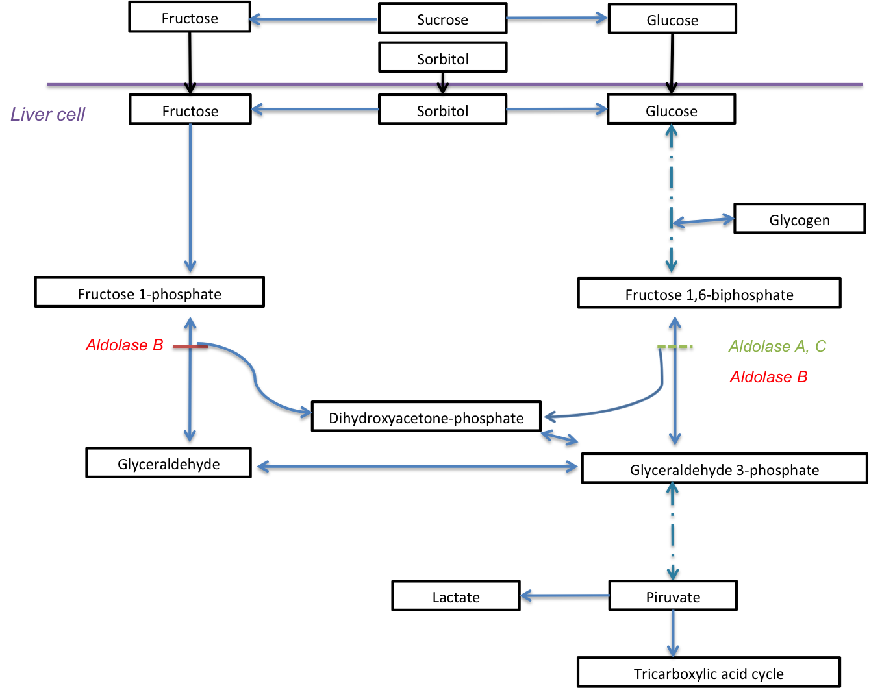

Fig. 1: Hepatic fructose metabolism in hereditary fructose intolerance (aldolase B deficiency).

